S.  N | Title | Submit Date | Sign
1. | Inference with logical deductions using swi-prolog | 2082/05/
2. | Implementing Classification Algorithm using Naïve Bayes | 2082/05/
3. | Implementing simple backpropagation algorithm using python. | 2082/05/
4. | Implementing regression model to predict housing prices. | 2082/05/

Lab: 1
TITLE: INFERENCE WITH LOGICAL DEDUCTIONS USING SWI-PROLOG
OBJECTIVES
- To understand how inference and logical reasoning are carried out using Prolog.
- To explore how facts, rules, and queries form the basis of a knowledge base.
- To perform logical queries and test inference mechanisms on the created knowledge base using SWI-Prolog.

THEORY
Artificial Intelligence (AI) is largely built on the idea of reasoning and decision-making through logical inference. One of the earliest and most fundamental approaches to AI is symbolic reasoning, where knowledge about the world is represented using symbols and relationships, and conclusions are drawn from these representations through logical deduction. Logic programming, particularly Prolog (Programming in Logic), provides a direct way to express such knowledge bases and query them systematically.

In Prolog, a knowledge base (KB) is composed of facts and rules. Facts represent basic information that is unconditionally true in the system. For example, girl(priya). asserts that Priya is a girl. Rules, on the other hand, describe conditional relationships between facts. For instance, likes(priya, jaya) :- can_cook(jaya). states that Priya likes Jaya if Jaya can cook. These rules reflect the use of implication in logic, where the truth of one fact depends on the truth of another.

The process of inference in Prolog is handled by its internal reasoning engine through a mechanism called backward chaining. When a query is asked, Prolog attempts to satisfy it by searching through facts and applying rules, tracing backwards to check if conditions hold true. This search strategy enables Prolog to answer complex queries by combining simple facts. For example, asking ?- can_cook(X). allows Prolog to infer all entities X for which the fact can_cook(X) is true.
Logical inference is powerful because it mirrors human-like reasoning. For instance, from simple facts such as “Lili dances” and a rule “Lili is happy if she dances,” Prolog can conclude that Lili is happy. Similarly, combining facts and conditions allows us to describe more complex real-world situations like friendship, hunger, or the decision to go out and play. This structured approach to reasoning is the cornerstone of many AI applications, from expert systems to knowledge representation and reasoning systems.

Overall, Prolog demonstrates how symbolic logic can be operationalized to build small-scale intelligent systems. While it may not be as fast as modern machine learning methods, it provides clarity in understanding how machines can reason using structured logical rules.

Syantax of proglog:
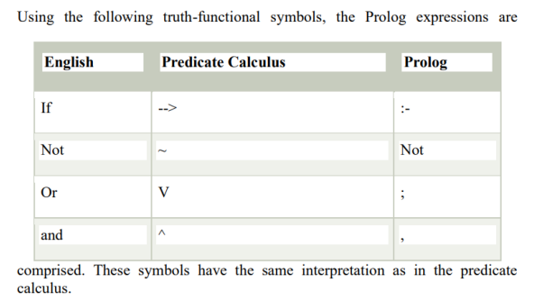

DEMOSTRATION

Facts :
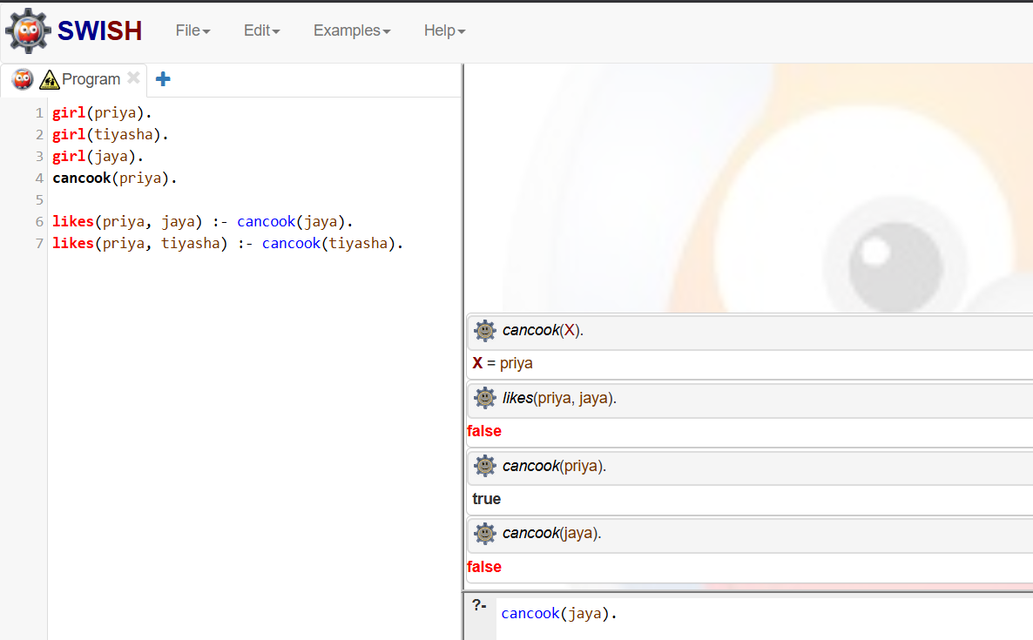
girl(priya).
girl(tiyasha).
girl(jaya).
can_cook(priya).

Rules:
likes(priya, jaya) :- can_cook(jaya).
likes(priya, tiyasha) :- can_cook(tiyasha).

Example Queries
- can_cook(X).
- likes(Priya, jaya).
- cancook(Priya).
- cancook(jaya).

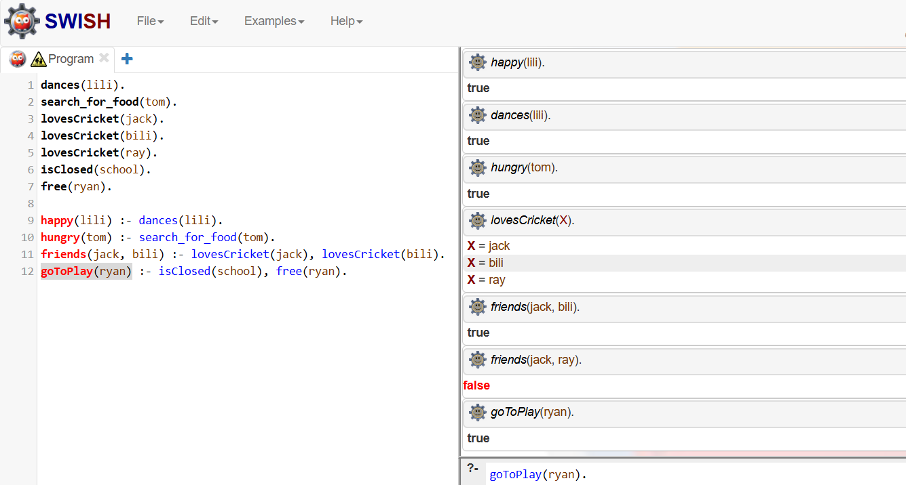
Additional Knowledge Base
RESULT AND DISCUSSION
In this experiment, we successfully created a simple knowledge base in Prolog consisting of facts and rules. By running queries, we observed how Prolog applies logical inference to provide answers. For instance, the query ?- can_cook(X). correctly identified Priya as the one who can cook. Similarly, when conditions were satisfied, Prolog was able to infer conclusions like “Lili is happy if she dances.” This demonstrates the fundamental reasoning ability of Prolog, where the system does not store precomputed answers but derives solutions dynamically based on logical relationships.
The experiment also highlighted how more complex rules can be built to represent real-world knowledge, such as defining friendship based on shared interests or deciding to play based on conditions like school being closed and having free time. Through these examples, it becomes clear how symbolic logic-based AI works by encoding knowledge in structured form and then applying inference rules to draw meaningful conclusions. This lays the foundation for understanding larger AI systems that rely on reasoning, such as expert systems, planning systems, and intelligent agents.

CONCLUSION
The experiment demonstrated how Prolog and logical inference can be used to represent knowledge and perform deductions. By building a small knowledge base and testing queries, we gained an understanding of how facts and rules interact in Prolog. This provides valuable insight into symbolic AI, where knowledge is explicitly represented and manipulated, as opposed to modern statistical learning approaches. Overall, the experiment reinforced the importance of logic programming in the history and foundations of Artificial Intelligence.

Lab: 2
TITLE: IMPLEMENTING CLASSIFICATION ALGORITHM USING NAIVE BAYES
OBJECTIVES
- To understand the working principle of the Naïve Bayes classification algorithm.
- To apply Naïve Bayes on a dataset and analyze results using Excel.
- To observe how conditional probabilities are used for classification tasks.

THEORY
Classification is a fundamental problem in Artificial Intelligence (AI) and Machine Learning, where the goal is to categorize data into predefined classes based on given features. Among various classification algorithms, Naïve Bayes is one of the simplest yet highly effective methods, particularly for text classification, spam detection, and medical diagnosis.
The Naïve Bayes classifier is based on Bayes’ Theorem, which describes the probability of a hypothesis HHH given some observed evidence EEE:
$$[P\left(H ∣ E\right)=\frac{P\left(E ∣ H\right)⋅P\left(H\right)}{P\left(E\right)}]$$
Here,
- $P\left(H ∣ E\right)$ is the posterior probability of hypothesis HHH after seeing evidence EEE.
- $P\left(E ∣ H\right)$is the likelihood of evidence given that the hypothesis holds.
- $P(H)$ is the prior probability of the hypothesis.
- P(E) is the probability of the evidence.
In classification, the hypothesis corresponds to a class label, and the evidence corresponds to the feature values of the instance to be classified. The classifier assigns a new instance to the class with the maximum posterior probability.

The assumption made by Naïve Bayes is that all features are conditionally independent given the class label. Although this assumption is rarely true in practice, the algorithm often performs remarkably well, even on datasets with dependent features.
In this lab, Naïve Bayes was implemented using an Excel sheet. The dataset contained features and class labels, and we computed prior probabilities, likelihood probabilities, and posterior probabilities to classify instances. The Excel formulas helped automate these calculations, making it easier to observe how each probability contributes to the final decision.

Naïve Bayes is especially useful because of its simplicity, efficiency, and ability to handle large feature spaces. However, it struggles when features are highly correlated or when continuous variables do not follow the assumed distribution (commonly Gaussian).

DEMOSTRATION
Final Result: The instance is classified as Yes because posterior probability of "Yes" is higher. (Given fig bellow:)
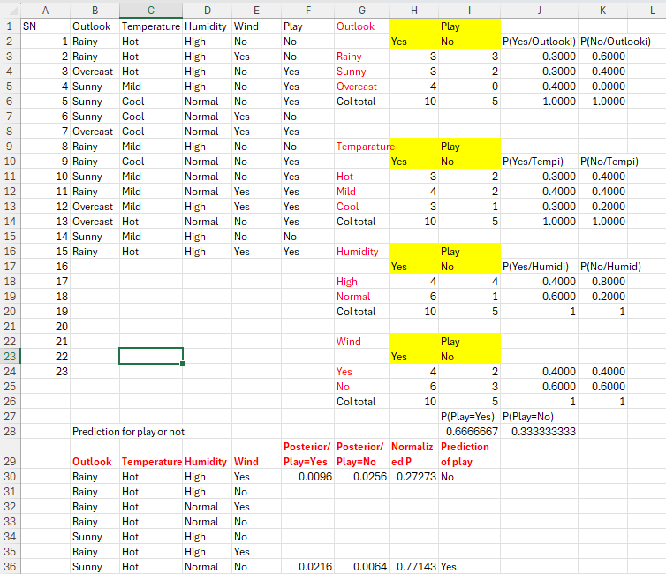

Steps followed in Excel:
- Data Preparation – The dataset was provided with input features and class labels.
- Prior Probabilities – Computed by dividing the frequency of each class by the total number of records.
- Likelihood Probabilities – For each feature value, conditional probabilities given a class were calculated.
- Posterior Probabilities – Using Bayes’ theorem, posterior probabilities were computed for each class.
- Classification Decision – The class with the highest posterior probability was assigned to the new data point.

RESULT AND DISCUSSION
The Naïve Bayes algorithm was successfully applied to the dataset using Excel. By calculating prior, likelihood, and posterior probabilities step by step, we observed how classification decisions are made mathematically. The results confirmed that the algorithm assigns each instance to the class with the highest posterior probability.
One of the key observations was how simple multiplication of probabilities can effectively capture the relationship between features and classes. Despite its independence assumption, the classifier provided reasonable results, showing why Naïve Bayes is widely used in practical applications such as spam filtering, document classification, and medical data analysis.

CONCLUSION
This experiment demonstrated the implementation of the Naïve Bayes classification algorithm using Excel. Through probability-based calculations, we understood how Naïve Bayes makes classification decisions. The lab highlighted the importance of Bayes’ theorem in AI and showed how a simple probabilistic model can achieve effective classification.
Lab: 3
TITLE: IMPLEMENTING SIMPLE BACKPROPAGATION ALGORITHM USING PYTHON
OBJECTIVES
- To understand the working of the backpropagation algorithm in neural networks.
- To implement a simple neural network using Python and NumPy.
- To observe how weights are updated during training and how the network output approaches the target value.

THEORY
Artificial Neural Networks (ANNs) form the basis of many modern AI applications, including image recognition, natural language processing, and autonomous systems. They mimic the functioning of the human brain by organizing artificial neurons into layers and passing information forward through weighted connections. The strength of these connections (weights) determines the response of the network to given inputs.
Training a neural network requires an algorithm that can adjust the weights so that the network’s output matches the expected target. The Backpropagation Algorithm is the standard technique for this task. It is essentially a supervised learning method that uses gradient descent to minimize the error between the predicted output and the actual target. The process involves two main stages:

- Forward Propagation: Input values are passed through the network, layer by layer. Each neuron applies a weighted sum followed by an activation function (in this case, the sigmoid function). This produces the predicted output.
- Backward Propagation: The error is calculated as the difference between the predicted output and the target output. Using the chain rule of differentiation, this error is propagated backward through the network. Gradients of the error with respect to each weight are computed, and weights are updated in the opposite direction of the gradient to reduce the error.

In this experiment, the network consisted of an input layer (2 neurons), one hidden layer (2 neurons), and an output layer (1 neuron). A sigmoid activation function was used, which squashes values into the range (0,1), making it suitable for small-scale examples. Unlike typical implementations with random initialization, here the weights were initialized with fixed values so that updates could be easily traced. This made it possible to observe clearly how weights were modified across training epochs.

Backpropagation is powerful because it can generalize to any differentiable activation function and any network depth. It is the foundation of deep learning, enabling neural networks to learn complex, non-linear decision boundaries. However, it also comes with challenges like sensitivity to learning rates, risk of getting stuck in local minima, and the vanishing gradient problem in deeper networks. Despite these issues, backpropagation remains the most fundamental learning algorithm for feedforward neural networks.

DEMOSTRATION

Basic structure:
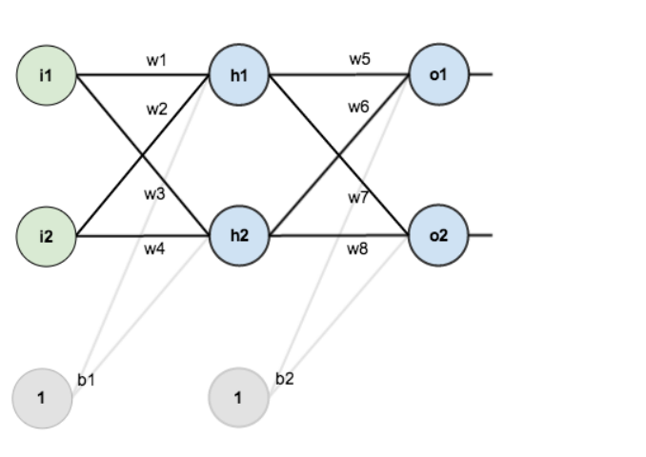\

Initial weights, the biases, and training inputs/outputs:
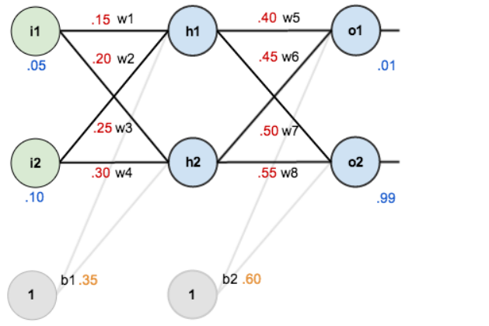

predicted output in epoch 1 :
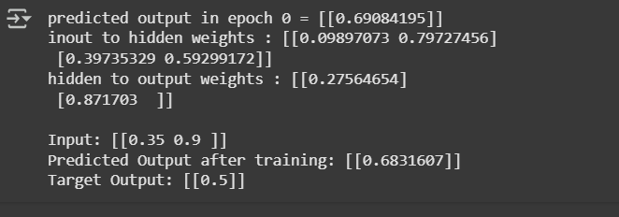

predicted output in epoch 50 :
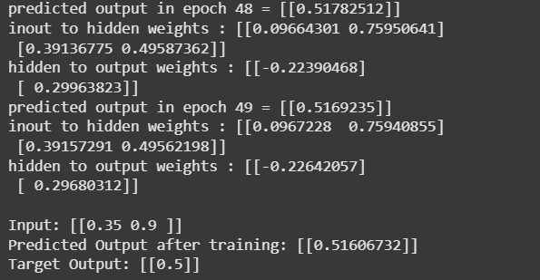
predicted output in epoch 100:
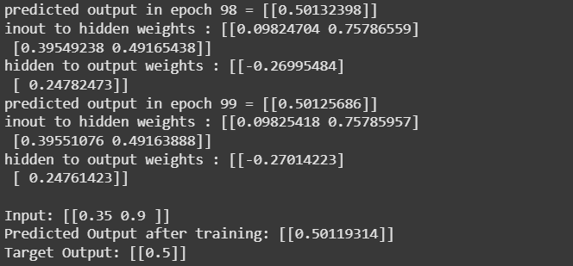

RESULT AND DISCUSSION
The experiment successfully demonstrated the implementation of the backpropagation algorithm in Python using a class-based neural network model. Starting from initial fixed weights, the network performed forward propagation to compute predictions and then used backward propagation to adjust weights based on the observed error. During training, the predicted output gradually shifted closer to the target output (0.5). By the end of 100 epochs, the predicted output was approximately 0.502, which is very close to the expected target.

CONCLUSION
In this experiment, we implemented a simple neural network with backpropagation using Python and NumPy. Through forward and backward passes, the network adjusted its weights and successfully minimized the error between predicted and target outputs. This provided a clear understanding of the mechanics of backpropagation, reinforcing its importance as the foundation of training neural networks in AI.

Lab: 4
TITLE: IMPLEMENTING REGRESSION MODEL TO PREDICT HOUSING PRICES.

OBJECTIVES
- To understand how regression can be applied to real-world problems for predictive modeling.
- To build and evaluate a regression model for predicting housing prices using the California Housing dataset.
- To analyze correlations between housing features and median house value.
- To implement regression using Python libraries such as Pandas, scikit-learn, and Statsmodels.

THEORY
Artificial Intelligence (AI) not only deals with symbolic reasoning and problem-solving but also with learning from data and making predictions. One of the fundamental techniques in this domain is regression analysis, which belongs to the class of supervised machine learning algorithms. Regression is widely used when the target variable is continuous and the objective is to model the relationship between independent variables (features) and the dependent variable (output).
In this experiment, we focus on linear regression, which assumes that the dependent variable can be expressed as a linear combination of the independent variables. Mathematically, it can be expressed as:

$$[y=β_{0}+β_{1}x_{1}+β_{2}x_{2}+…+β_{n}x_{n}+ϵ]$$
Here,
- y = predicted output (median house value),
- $β_{0}$​ = intercept,
- β₁, β_{2,} β₃ …… β_{n}​ = coefficients representing the effect of each feature,
- ϵ = error term.
The California housing dataset contains attributes such as longitude, latitude, median income, housing age, total rooms, total bedrooms, population, and households. The target variable is median_house_value, which we want to predict. Before applying regression, it is essential to handle missing values, split the dataset into training and test subsets, and explore correlations to understand which features strongly influence the target.
To evaluate the model, we use statistical measures such as the R-squared value (R2R^2R2), which indicates how much of the variance in the dependent variable is explained by the independent variables. A higher R2R^2R2 means the model fits the data better. Additionally, analyzing residuals (differences between actual and predicted values) is critical to check whether the assumptions of regression (linearity, homoscedasticity, independence, and normality of errors) are reasonably satisfied.
This lab also uses Statsmodels, which provides detailed regression summaries, including p-values, confidence intervals, and adjusted R2R^2R2, giving deeper insights into the significance of each feature. By completing this experiment, we demonstrate how regression can be applied in practice to predict housing prices and how statistical analysis supports decision-making in AI and Data Science.

DEMOSTRATION
California Housing Dataset:
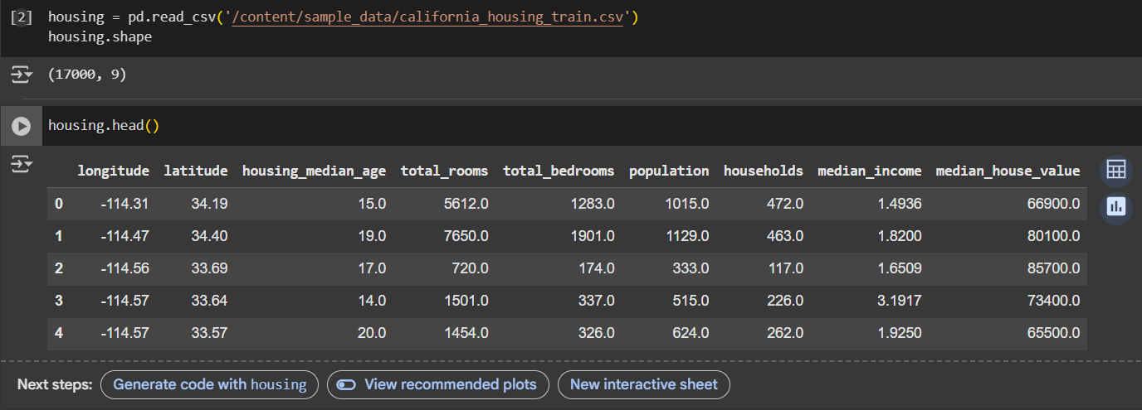
Housing describes:
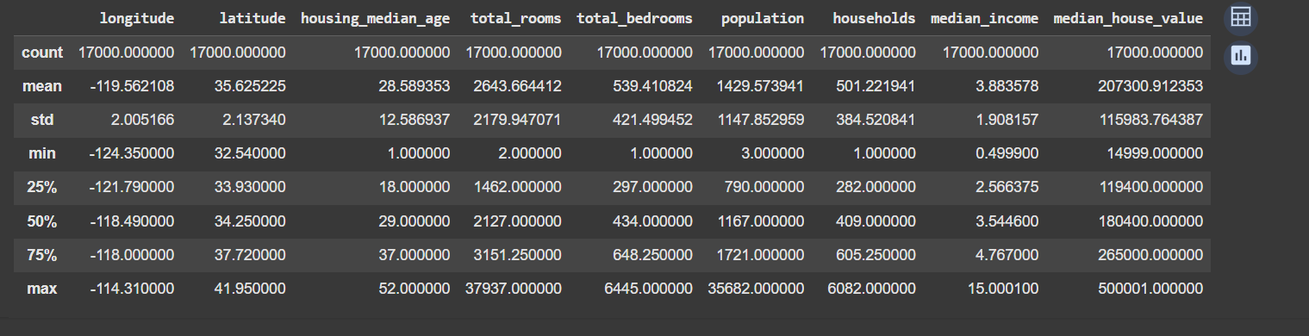
Histogram Information:
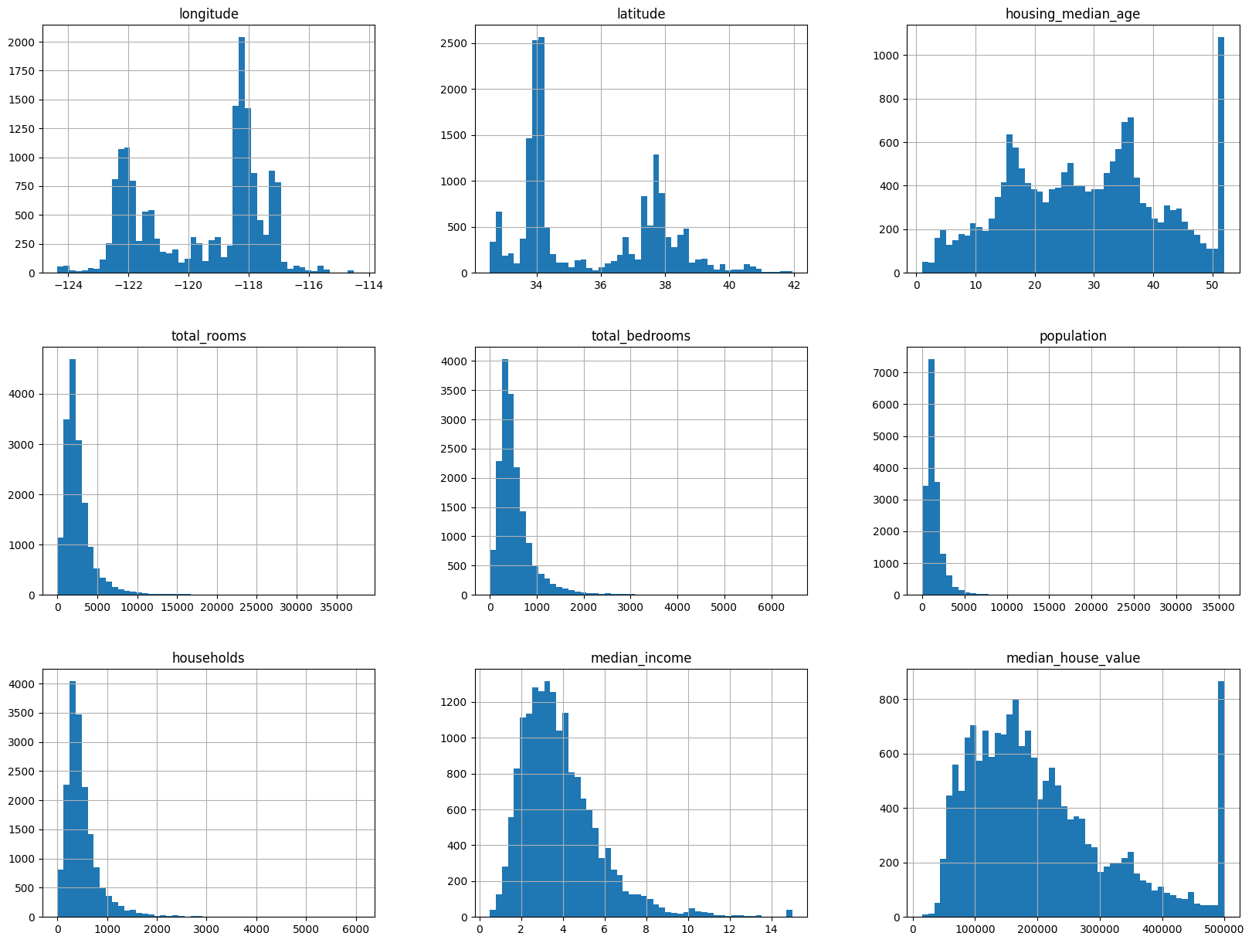

Regression graph:
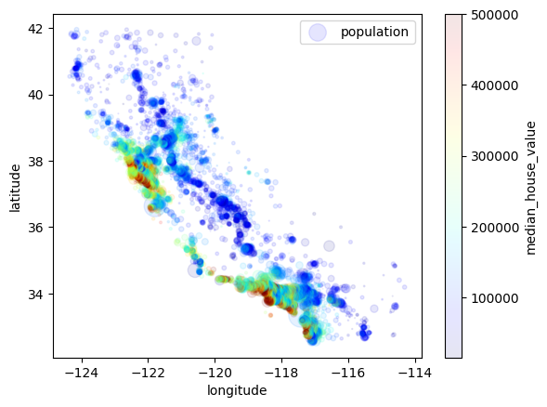

Residuals vs Observations:
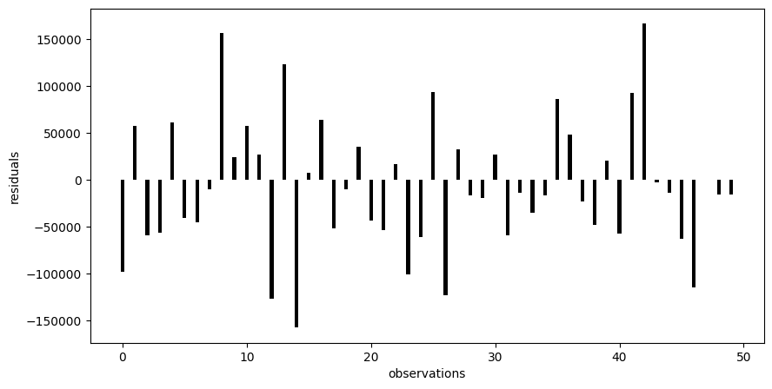

Summary:
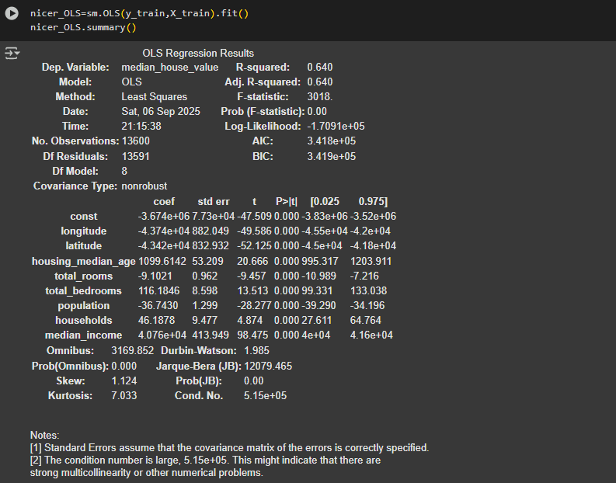

RESULT AND DISCUSSION
The regression model was successfully implemented and tested on the California housing dataset. The results revealed that median income was the most influential feature in predicting house prices, while geographical attributes like longitude and latitude also contributed to price variation. The model achieved an R2R^2R2 score of approximately 0.64, indicating that about 64% of the variance in house prices was explained by the chosen features.
Residual plots showed that most prediction errors were randomly distributed, suggesting that the linear regression assumptions were mostly valid. However, slight deviations hinted at the presence of non-linear relationships that the linear model could not fully capture. The Statsmodels summary provided additional statistical evidence, such as p-values, which confirmed the significance of key features like median income.

CONCLUSION
This experiment successfully demonstrated how regression can be applied to predict housing prices using real-world datasets. By building and training a linear regression model, analyzing residuals, and interpreting statistical summaries, we gained insights into both the predictive power and limitations of linear regression. The lab reinforced the role of regression in AI and Data Science, bridging statistical analysis with machine learning for practical problem-solving.

